1️- Series Resistor
Resistor load ke line me lagta hai.

👉 KYU lagate hain?
- Current limit karna ho
- Voltage drop chahiye ho
- Load ko protect karna ho
👉 Kya effect hota hai?
- Current kam hota hai
- Load par voltage kam milti hai
👉 Real Life
- LED ke saath resistor
- IC input protection
👉 Series = rokna / limit karna 🚦
2️- Parallel Resistor
Resistor side me lagta hai (extra path).
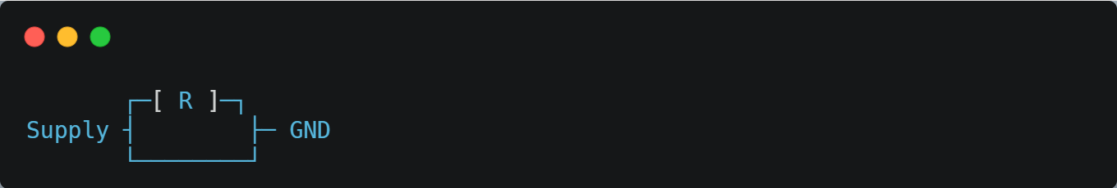
✅ Reason 1: Current share karne ke liye
Ek resistor par zyada load ❌
2 parallel resistor → current divide ✔
👉 Power handling badh jaati hai 🔥
--------------------------------------------------------------------------------------------------------------------------------------
1️ Series Resistor
series me lagayenge to jyada voltage drop hogi but current same rehega
✅ Bilkul Correct 👍
🔹 Explanation
- Series circuit me sirf ek hi current path hota hai
- Isliye har component me SAME current flow karta hai
- Har resistor apne value ke hisaab se voltage drop karta hai
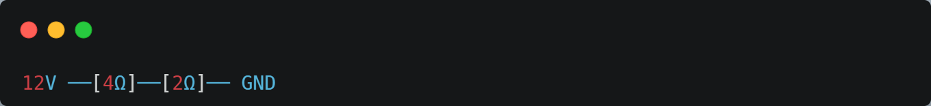
- Current = 12 / (4+2) = 2A
- Voltage drop =
  - 4Ω → 2×4 = 8V
  - 2Ω → 2×2 = 4V
✔ Current same, voltage divide ✔
2️- Parallel Resistor
👉 Aapka statement:
parrallel me voltage same rhegi but current devide ho jayega
✅ Ye bhi Bilkul Correct 👍
🔹 Explanation
- Parallel circuit me same voltage source sab branch ko milta hai
- Isliye har resistor par SAME voltage hoti hai
- Lekin resistance alag hone ki wajah se current divide ho jata hai
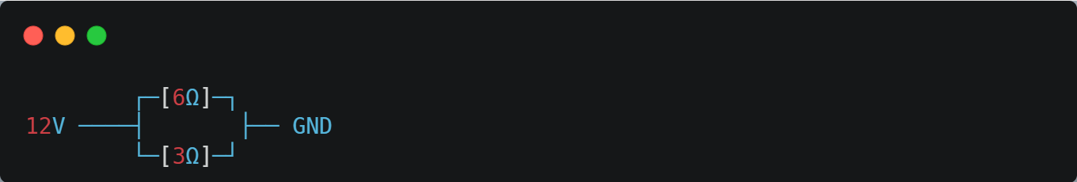
- 6Ω branch → 12/6 = 2A
- 3Ω branch → 12/3 = 4A
✔ Voltage same, current divide ✔

Note:
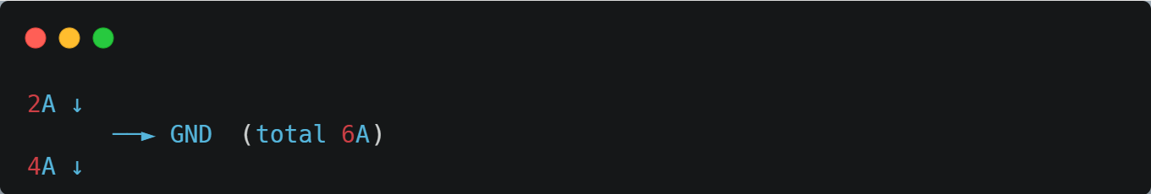
👉 Total current = 2A + 4A = 6A
⚠️ Yahan voltage add nahi hoti,
sirf current add hota hai.
🔑 Big Clarification (MOST IMPORTANT)
- ❌ “−2 voltage” jaisa kuch nahi hota yahan
- ✔ GND par voltage 0V hi rehti hai
- ✔ Jo add hota hai wo current hota hai, voltage nahi
Parallel me:
– Same nodes ⇒ Same voltage
– Alag resistance ⇒ Alag current
– Node par milte waqt ⇒ Current add hota hai
Golden Rule (Exam / Practical ke liye)
- Series:
👉 Current = same
👉 Voltage = divide
- Parallel:
👉 Voltage = same
👉 Current = divide
One-Line
Series = Voltage batta, Current same
Parallel = Current batta, Voltage same

